**Date 25/Sep/24**

**Syed Najaf Ali 27662**

**Eye Diseases**

**What is Glaucoma?**

Glaucoma is defined as a group of eye disorders leading to progressive damage to the optic nerve (Optic disc). It is characterized by the loss of nerve tissue that results in loss of vision.

While mild-to-moderate open-angle glaucoma is very common, many people are unaware of their condition, especially in the early stages, when their vision may be unaffected. In many people, open-angle glaucoma is characterized by an increase in the intraocular pressure (IOP) of your eye. The pressure is caused by the buildup of fluid within the eye; **too much fluid raises pressure, which can cause the gradual loss of vision.** And while glaucoma moves slowly, its damage is irreparable.

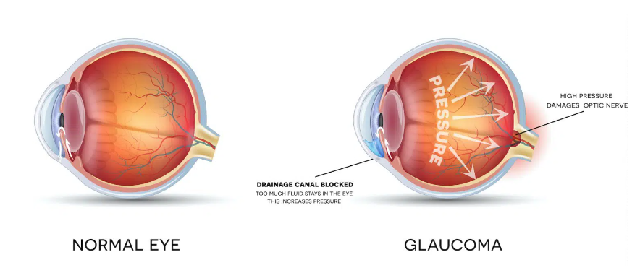

**Types of Glaucoma**

* Open-angle glaucoma
* Closed-angle glaucoma
* Normal-tension glaucoma
* Congenital glaucoma [Reference](https://southgeorgiaeye.com/eye-care-services/glaucoma-treatment/)

**How common is Glaucoma? (Globally)**

Glaucoma is a common age-related eye issue that **affects an estimated 3 million folks globally**, it’s the second leading cause of blindness after cataracts.

**Symptoms of Glaucoma?**

People want to know what the early warning symptoms of glaucoma are. The problem is that for some types of glaucoma, there aren’t any early warning symptoms, and changes to vision can happen gradually, so the symptoms are easy to miss. Because many people with open-angle glaucoma don’t have any noticeable symptoms, it’s very important to have routine eye exams to detect this disease in its earlier stages. **Glaucoma damage is irreversible**, so **you need early detection and treatment to prevent blindness.**

Closed-angle glaucoma has more severe symptoms that tend to come on suddenly. with any type, you may experience:

* Eye pain or pressure.
* Headaches.
* Rainbow-colored halos around lights.
* Low vision, blurred vision, narrowed vision (tunnel vision) or blind spots.
* Nausea and vomiting.
* Red eyes.

**Causes of Glaucoma?**

Glaucoma can occur without any cause, but many factors can affect it. The most important of these factors is intraocular eye pressure. Your eyes produce a fluid called aqueous humor that nourishes them. This liquid flows through your pupil to the front of your eye. In a healthy eye, the fluid leaves through the drainage canals located between your iris and cornea.

**Glaucoma risk factors**

A serious eye disease, Glaucoma is the second leading cause of blindness in the United States. Glaucoma most often occurs in **people over age 40,** although a congenital or infantile form of glaucoma does exist. People with a family history of glaucoma, African Americans over the age of 40, and Hispanics over the **age of 60** are at an increased risk of developing glaucoma. Other risk factors include thinner corneas, chronic eye inflammation [Reference2](https://my.clevelandclinic.org/health/diseases/4212-glaucoma)

Glaucoma can affect anyone, but the risk increases with age. **People who are Black and Hispanic are much more likely to get glaucoma than other ethnic groups**, and they tend to develop the disease earlier in life. Asian and Inuit populations are also more susceptible to a specific form of glaucoma known as angle-closure glaucoma or closed-angle glaucoma.

Other risk factors include

* Family history of glaucoma.
* Farsightedness or hyperopia (for closed-angle glaucoma).
* High blood pressure (hypertension and very low blood pressure (hypotension)
* Long-term use of corticosteroids.
* Nearsightedness or myopia (for open-angle glaucoma).
* Previous eye injury or surgery.

**How is glaucoma diagnosed?**

It’s possible to have glaucoma and not know it. Regular eye exams are important to catch glaucoma or other eye problems. Eye exams can assess optic health and vision loss.

To check for glaucoma, an eye doctor may do one or more of these painless tests

* Dilated eye exam to widen pupils and view your optic nerve at the back of your eyes.
* Gonioscopy to examine the angle where your iris and cornea meet.
* Optical coherence tomography (OCT) to look for changes in your optic nerve that may indicate glaucoma.
* Ocular pressure test (tonometry) to measure eye pressure.
* Pachymetry to measure corneal thickness.
* Slit-lamp exam to examine the inside of your eye with a special microscope called a slit lamp.
* Visual acuity test (eye charts) to check for vision loss.

[Reference 3](https://my.clevelandclinic.org/health/diseases/4212-glaucoma#diagnosis-and-tests)